DATA & SCIENTIFIC METHOD Name _______________________________________

1 | 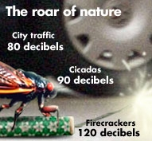 | Independent Variable:  Dependent Variable:  What is the scientific question?  Control Group:  Experimental Variable Group:
2 | 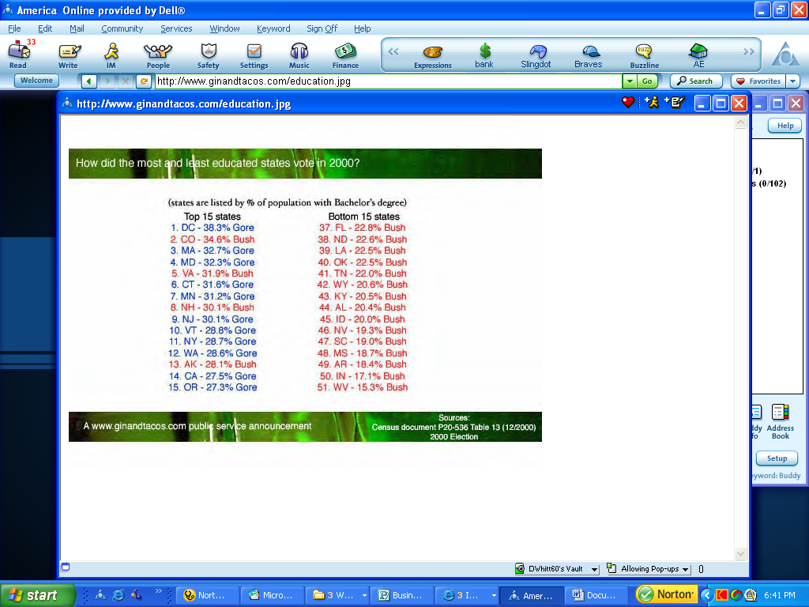  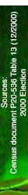  Average IQ & 2000 President Election | Independent Variable:  Dependent Variable:  What is the scientific question?  Control Group:  Experimental Variable Group:
3 | 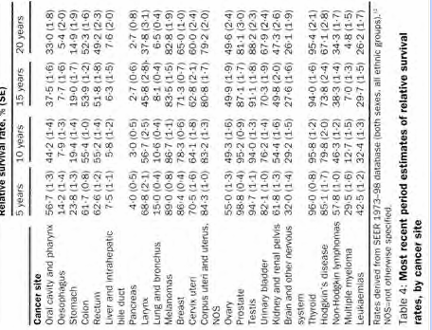 | Independent Variable:  Dependent Variable:  What is the scientific question?  Control Group:  Experimental Variable Group:
4 | 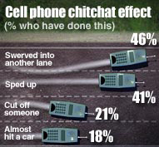 | Independent Variable:  Dependent Variable:  What is the scientific question?  Control Group:  Experimental Variable Group:
5 | Oxygen can be generated by the reaction of Hydrogen Peroxide with Manganese Dioxide | Independent Variable:  Dependent Variable:  What is the scientific question?  Control Group:  Experimental Variable Group:
  Tube # | MnO₂ (g) | 1 min (ml O₂) | 2 min (ml O₂) | 3 min (ml O₂) | 4 min (ml O₂) | 5 min (ml O₂)
  1 | 0.1 | 1.4 | 2.6 | 3.5 | 4.2 | 5.1
  2 | 0.2 | 2.8 | 4.6 | 5.8 | 7.1 | 7.6
  3 | 0.3 | 4.9 | 7.2 | 8.8 | 10.2 | 11.3
  4 | 0.5 | 5.9 | 8.5 | 10.4 | 11.8 | 13.3
  5 | 1.0 | 8.5 | 12.4 | 14.4 | 16.1 | 17.1
  6 | 1.5 | 11.0 | 14.8 | 17.5 | 19.8 | 21.8
  7 | 2.0 | 12.0 | 17.0 | 20.2 | 22.7 | 24.8
  8 | 2.5 | 13.6 | 19.0 | 22.1 | 24.7 | 27.3
  9 | 3.0 | 16.2 | 21.8 | 25.1 | 28.2 | 30.4
6 | Ethylene is a plant hormone that causes fruit to mature  . | Independent Variable:  Dependent Variable:  What is the scientific question?  Control Group:  Experimental Variable Group:
  Amount of ethylene in ml/m² | Wine sap Apples:  Days to Maturity | Golden Apples:  Days to Maturity | Gala Apples:  Days to Maturity
  10 | 14 | 14 | 15
  15 | 12 | 12 | 13
  20 | 11 | 9 | 10
  25 | 10 | 7 | 9
  30 | 8 | 7 | 8
  35 | 8 | 7 | 7

